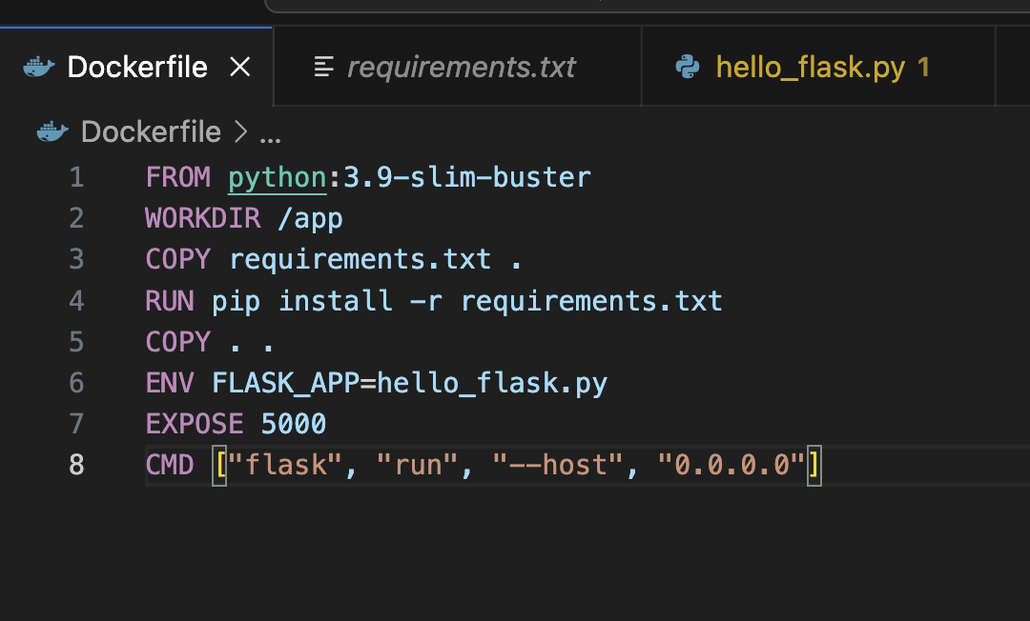

FROM python:3.9-slim-buster

WORKDIR /app

COPY requirements.txt .

RUN pip install -r requirements.txt

COPY . .

ENV FLASK_APP=hello_flask.py

EXPOSE 5000

CMD ["flask", "run", "--host", "0.0.0.0"]

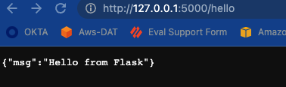

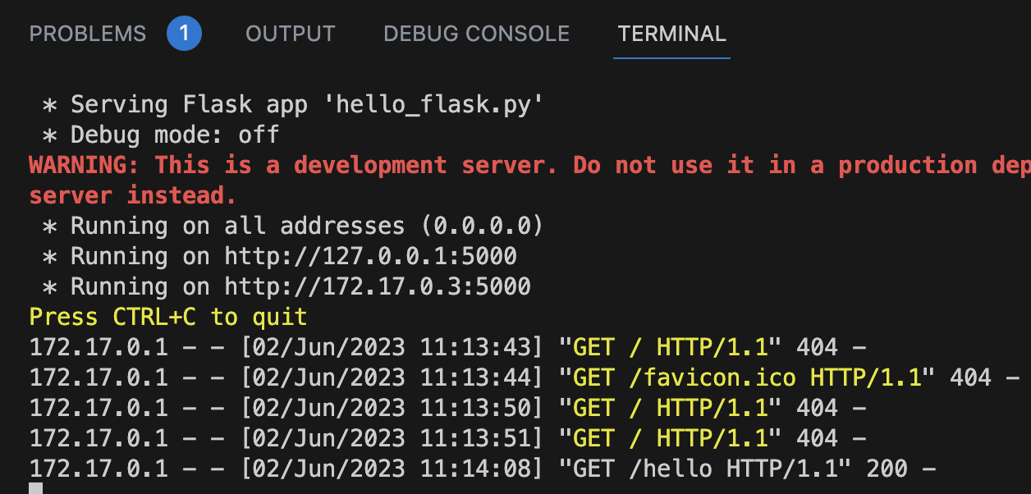

Day len dockerhub

dattran@M-J40PFC4GC4 docker_flask % docker tag my_flask:02 dangkiabcd/my_flask:02

dattran@M-J40PFC4GC4 docker_flask % docker push dangkiabcd/my_flask:02

